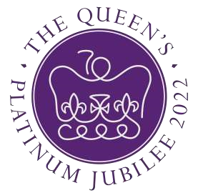

The Newsletter for Middleton on the Wolds

Issue No 38

JUNE 2022

NEXT COPY DATE

14th JUNE

Please send in your contributions by the end of the copy date. If I don’t acknowledge them please get in touch to make sure they have arrived.
If you are able to send your copy in earlier please do as it will help me to avoid the rush in getting the newsletter ready for the printer.
Thank you
Lyn
4 The Paddocks 219500 middletonflyer@yahoo.com
Jubilee Weekend Events in Middleton

Thursday 2nd
12.30pm Gala on the school playing field (page 14)
7.30pm The History Wardrobe in the Village Hall (page 15) 9.45pm Lighting the Beacon at Beacon Park (page 21)

Friday 3rd
from 10.00 Jubilee Flower Displays in St Andrew’s Church (page 13)
7.30pm Edwina Hayes Entertains in the Village Hall (page 16)

Saturday 4th
from 10.00 Jubilee Flower Displays in St Andrew’s Church (page 13)
2.00pm Afternoon Teas with Andy Lloyd in the Village Hall

Sunday 5th
Street Parties around the village (recipe suggestion page 23)

Editorial
Less on my soap box this month and more about hoping all of you take full advantage of what is going on in the village.
A few days after you read this we will be in full swing
celebrating the Platinum Jubilee. All the events are listed or advertised elsewhere in the Messenger so all I want to do is to encourage you to attend as many events as you can. When you get to the gala make sure you have a look at the stands representing the various groups active in the village. You never know, you might find something you never knew you’d been missing! Stay safe, Mike

If you have any ideas, comments or complaints (especially complaints) you want to share then send an email to middletonflyer@yahoo.com.
Remember, we can’t respond unless we receive your message.

ADVERTISING COSTS for the Messenger

Rates Month Year
Whole Page £25 £150
1/2 Page £15 £100
1/3 Page £10 £60

Full colour - Print run 500 copies
Contact: Tina 01377 217242, middletonflyer@yahoo.com

QUIZ PAGE
- As a toddler, Princess Elizabeth found it difficult to pronounce her name. What was she called at home instead?
- What did young Elizabeth call her grandfather, King George V? Grandpa Five, Grandpa King, Grandpa England
- Aureole’s second place in the Queen’s coronation year, 1953, is the closest one of Her Majesty’s’s horses have ever come to winning which celebrated race? The Grand National, The Cheltenham Gold Cup, The Derby
- The Queen’s favourite tipple, often taken at 6pm, is a 50/50 mixture of…?
'Vodka & Martini, Dubonnet & Gin, Port & Brandy
- Which doll has been presented to the Queen for her Jubilee?
- How many Queen Elizabeth's have there been?
- What is the name of her Scottish Royal Palace?
- Which of these actresses won an Oscar for her portrayal of the Queen? Kate Winslett, Helen Mirren or Emma Thompson?
- How many Great Grandchildren does the Queen have?
- Who was her first serving British Prime Minister?
- Bonus Question How much is the Queen worth?
Quiz set by Rowland Wooldridge
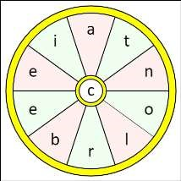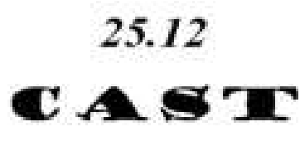
All answers on
page 23

JUBILEE WORD WHEEL

Try to find the timely word and then
create as many words possible with the
letters in the word wheel. You can only
use each letter once and every word
must include the letter in the centre of
the wheel.

ROYAL DINGBATS

correspondence
An interesting message from a former resident:
Although I have been out of the village since 1962 I still like to follow what is happening in Middleton. I moved into No5 South Drive when I was 2 yrs old moving from the main st (teapot row). The last house I stayed in with my parents was No 27 South St. (first bungalow). I then had to go into the army. When I came out of the army I got a job with Deans and Light Alloys in Beverley. Made redundant and got a job at Wiles of Woodmansey. I left and moved up to Scotland in 1962 where I have lived ever since, getting married in 1964.

I have managed to visit Middleton two or three times since I left. I noticed in one of your articles there are a few people still living aged 90 and over. I am 85 and often wondered if I would be one of the oldest if I still lived there. I don’t have any communication with anybody there and am curious if there would be anyone there who remembers me. My father (Harry Gee) was very well known. He did one year start the Kiplingcotes Derby and was able to be driven to the finishing gate before the horses arrived. Thank you for reading this.

Kenneth Gee
kenandelsieg@gmail.com

Local Birds & wildlife
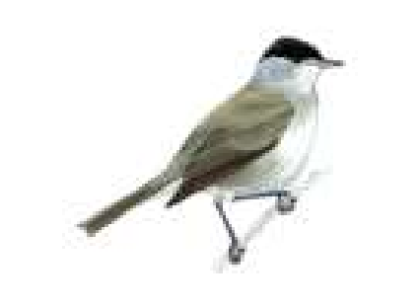
There’s a strong feeling of Spring being in full swing now; hawthorn bushes dripping with blossom, the dawn chorus blasting away first thing and baby birds hurtling around at low levels and crashing into bushes. The dark side of course is the competition for mates and nest-building sites. We found two male chaffinches fighting viciously just by the house; in the course of the battle they flew up and hit the
Black
-
cap

patio door. When we moved and the top bird flew, off the other eventually turned on to it’s front, but it was an hour before it recovered enough to fly away.
Happier things in our garden: greater spotted woodpecker visiting the feeder again, a blackcap drinking from the pond, chiff-chaffs getting more and more insistent on the embankment and brimstone and tortoiseshell butterflies. I have an embarrassing confession – I always ID white butterflies as ‘cabbage whites’ but in fact there seem to be a lot of white butterflies with a variety of dark spots and dark wing-edges, so I need to look a lot more closely! I bet their caterpillars all munch the juicy leaves of our favourite vegetables though … At least small blue butterflies are very small and very blue, and have just started appearing again. I really like things whose appearance tells me their names. The comfrey is covered with an encouraging number of bees, which vary from black to ginger and all points in between, all with bulging bags of pollen on their legs. Starlings are nesting on our house above the drive, and the poor car is getting bombarded as they go in and out so it has crept further under the carport so that at least we can see out of the windscreen…
I have been sent some lovely pictures this month! Tina’s hedgehog, Barry and Janny’s greenfinch family and Pat’s bunnies and French (or red-legged)
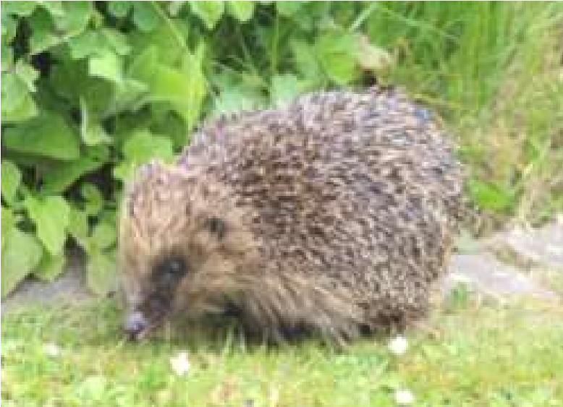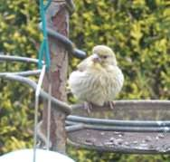
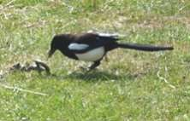
partridge. B & J also had an interesting sighting in Suffolk (ok, I know that is not very local) of a magpie catching and killing a grass snake, but then finding it too big to eat. They reported “Even the wardens there have not seen this!”

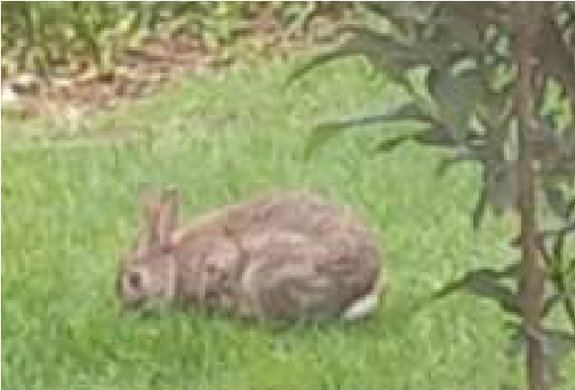
Pat reported on 1st May that house martins are back nesting at the front of the house, and that they had an Easter Day surprise: “Another four bunnies. I think they consider our garden their home territory. They all live under my shed. They will benefit from a No Mow May!”
Easter Bunnies – we did have a very nice Easter Bunny at the Fair in the Village Hall as well of course!
It is lovely hearing swifts again over the village isn’t it – last year was very poor for house martins, swifts and swallows. Still no reports of swallows, but I’m keeping my fingers crossed.
I think this column will be taking over the whole Messenger this month if I’m not careful, so I will just briefly mention a phone app called “Merlin” by the Cornell Lab – it listens to birdsong and identifies the birds for you – seems to be brilliant, but I know someone who tried to download it and was told it would cost £36 per year, while I and the person who recommended it to me are getting it for free. (One of us Android and the other IPhone). So be careful!
Hope you are enjoying your spring and please let me know your sightings, bird and animal behaviour you have seen and anything else fun that you would like to share! It’s amazing what turns up – Hazel saw 2 snipe flying by her garden earlier in the spring, and Amanda reports a lot of white pheasants in and around Nunburnholme Woods.
Barbara (apparently now a ‘retro’ name for new babies!) lavenderbarbara97@gmail.com or text on 0777 192 7868

LOCAL HISTORY
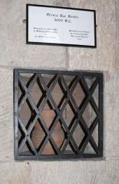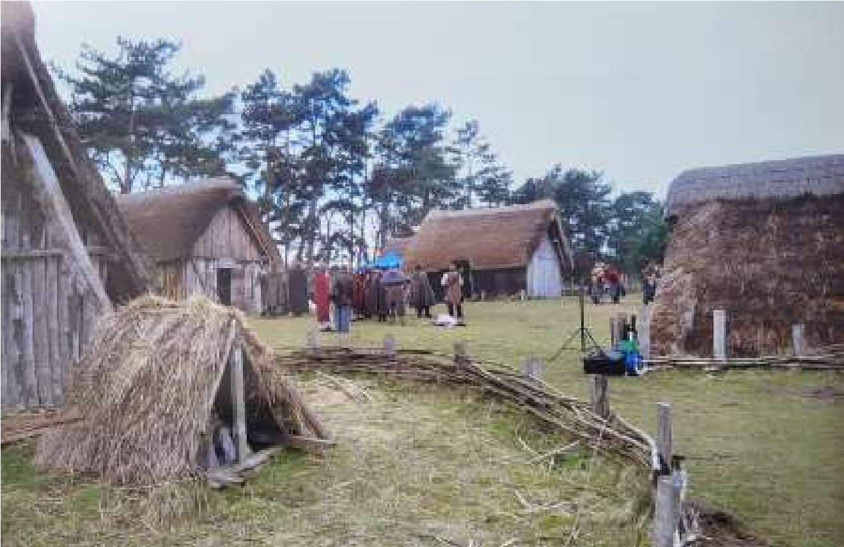

LIFE IN MIDDLETON

There is evidence of human activity on the
Wolds and in East Yorkshire from the earliest
days; that is before and after the physical
landmass of Britain was severed from Europe
which we are told was probably the result of a
gigantic tsunami which occurred about 6,100 BC
in the mid stone age; an event which made the
later idea of
“
Our Island Nation
”
a reality. No
doubt in ancient times the feet of man trod on the
ground which was to become Middleton and at
this stage before agriculture they were those of
hunter gatherers.

We have to move on a bit for early finds in
Middleton such as an iron and stone bracelet and
a bone ring from the Iron Age displayed in the
Hull Museum; and a Bronze Age beaker
displayed in the church. In 1921 during the extension to the quarry and factory situated on the North Dalton Road on the parish boundary by the owner Mr E B Lotherington a skeleton and dark Roman earthenware were found leading the Hull Museum curator, the famous Thomas. Sheppard, to speculate in his report that there may have been a Roman Camp or villa in the vicinity.
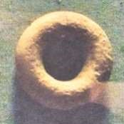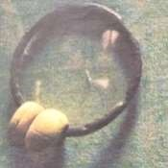

The native Iron Age tribe which inhabited East Yorkshire before and during the Roman occupation was referred to as Parisi because of its supposed connection with the area which today forms part of the district south of Paris in northern France. They were famous for their chariot burials, a practice they shared with their continental counterparts. A probable burial of this type together with other Iron Age and Roman graves was encountered during the excavation of a railway cutting between Middleton and Enthorpe in 1888 in a chalk pit. More recently in the year 2000 a chariot burial was discovered on a proposed building site in Wetwang with subsequent excavations revealing that the skeleton found was that of a woman together with feminine artifacts and the remains of a pig: she must have been a lady of importance to have warranted such a burial.
The Romans appear to have hit it off with the native population when they arrived in East Yorkshire in the 70s AD and it is thought that the Parisi were either indifferent or friendly towards the newcomers with agriculture becoming geared up to provide for the increased population. Later in the occupation the more able and amenable members of the native population saw fit to become Romanized with favoured individuals occupying well appointed centrally heated villas such as the one excavated at Rudston with its mosaic floor now displayed in the Hull museum. All good things come to an end however.
By the beginning of the fifth century the Roman Empire itself was under attack by barbarians in the western provinces and the army was needed to defend this territory on mainland Europe so in AD 410 the emperor Honorius told the cities of Britain to defend themselves; although there is an opinion that he thought their departure might not be permanent: it was.
The Anglo-Saxons had been present in Eastern England before the Roman departure and may have been used as mercenaries with some doubt existing

about the exact manner of their achieving dominance in the post Roman society. The whole period was once known as the Dark Ages but in recent times historians have had second thoughts about this as they have with the extent of the later Viking incursions. An aura of mystery surrounds the period following the Roman departure and the world loves a mystery. What is known however is that these were years of turmoil when rival “kings” aided by the force of warrior bands vied for power in tribal conflicts which resulted in expanded kingdoms with East Yorkshire forming part of the kingdom of Deira and by the time of Athelstan, the first king of all England from 924, part of Northumbria.
A word about religion. The Romans in the main were tolerant of other religious practices so long as they could absorb them in their own scheme of things. In the year AD 312 the emperor Constantine was converted to Christianity for reasons that have remained unclear and Christianity existed in Britain: Eborius of York was among three British bishops who attended the Council of Arles in 312. A defining moment in the conversion of the area to the new religion came in 627 when King Edwin who had married a Christian princess Ethelburga from Kent had the high priest Coifi destroy the pagan temple at Goodmanham a few miles from Middletion and said to be near the royal palace. In the centuries to come the church and religious institutions together with leftover beliefs from pagan practices would play an important part in people’s lives.
What is not certain is whether the blended population lived in scattered settlements or more substantial villages such as the one excavated at West Heslerton. By the eighth and ninth centuries however the present pattern of villages, to be known for centuries as “Townships”, would have been established with names that exist today. The ending “ton” is an Anglian one which means a settlement or small estate in the countryside that had been cleared for arable farming. Some villages were to have names of Viking origin the result of the expedition which sailed up the Humber in 867 and took York with little resistance. Little is known of the impact of the invasion on the day to day existence on the Wolds but after 876 the division of Yorkshire (Deira) into three Ridings was established and York (Jorvik) became a busy town full of tradespeople and craftsmen. This period which had seen the replacement of Roman infrastructure and lifestyle by the beginnings of English society came to an end in that most famous year of British history: 1066.
Geoff Wisher

St Andrew’S church
Notice: The Benefice Holy Communion will be held at Kirkburn at 10.00am on Sunday 29th May. Rev’d Jane and ministry team

Services for June
Sunday 5th | 10.30am | Special service of thanksgiving for the
 |  | Queen’s Jubilee. Holy Communion
 |  | Rev`d Jane Anderson
Sunday 12th | 10.30am | Trinity Sunday. Joint service of Holy
 |  | Communion at St Andrew’s Church Bainton.
 |  | Rev’d Jane Anderson
Sunday 19th | 10.30am | Holy communion.
 |  | Rev’d Canon Kate Goulder
Sunday 26th | 10.30am | Holy Communion. Rev’d Ruth Newton

The wolds METHODIST CHURCH
Services for June
Sunday 5th 10.30am Church, Middleton | Jubilee Thanksgiving Service at St Andrew’s
Sunday 12th 10.30am | Service at Wetwang Methodist Church,
Sunday 19th 10.30am | Service at the Wolds Methodist Church.
 | Mr Stephen Byass
Sunday 26th 10.30am | Service at the Wolds Methodist Church,

a note from your vicar
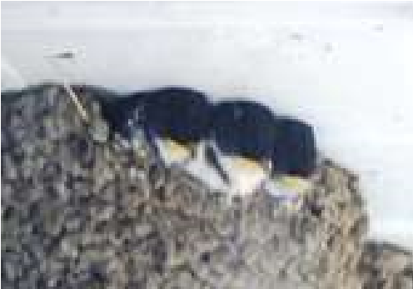
Help Save our Feathered Friends
We are very fortunate at the Rectory to have two families of House Martin’s nesting under the eaves. Their carefully constructed homes, which take a pair of Martins around 10 days to construct, are made up of around 1000 beak size mud pellets,
and contain an incredible number of young. Watching these graceful creatures take flight and hearing their young calling for food as their parents dart back and forth has become something I look forward to each year. There are many names for a group of House Martins but I like a ‘flight’ or ‘swoop’, which seems to well describe these agile little birds.
The UK is estimated to have around 480,000 pairs, however, they have recently been added to the ‘Red List’ which means they are globally threatened, have suffered severe decline in the past 25 years and need urgent action to reverse this situation.
There are things we can do to support these special birds, such as encouraging the insects they eat into our gardens by leaving a small area un cut, build a swift box, or have a small bog garden. The Wildlife Trust and the RHS have joined forces to offer lots of ideas and advice on how we can all
‘act for nature’ – you can find out more at wildaboutgardens.org.uk
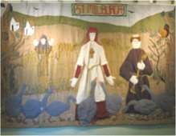
Milburgha (Milburga) of Much Wenlock is the Patron Saint of Birds. She was daughter to one of the Kings of Mercia – one of the seven Kingdoms of Anglo Saxon Britain. She was either gifted or founded a nunnery at Wenlock (now Much Wenlock) and it flourished under her leadership – not least because of her reportedly remarkable power over birds, for it was said that she could dissuade them from eating the farmers’ and convents’ crops. She also had the gift of
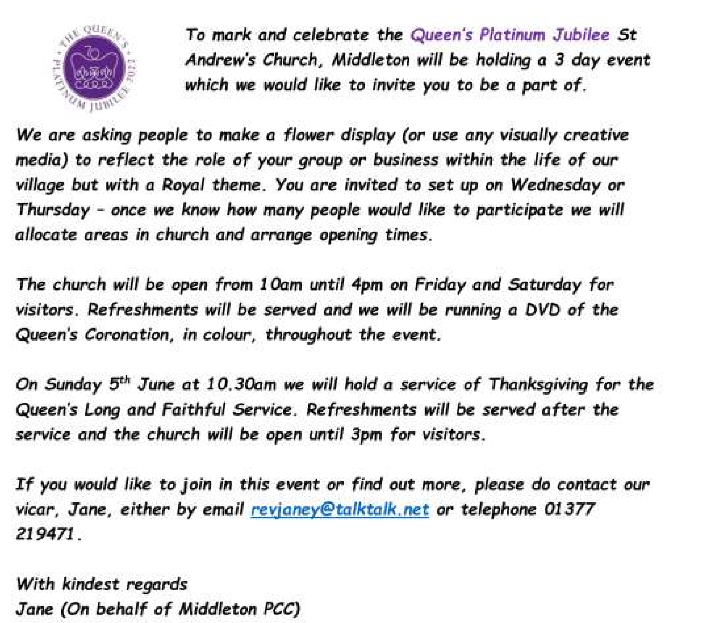
healing and many turned to her in their time of need. Milburgha died on the 23rd February 715 and her sister nuns buried her in front of the chapel alter where she remained, undisturbed, until a century later when Viking raiders ransacked the Abbey and destroyed the building. The location of her tomb was lost and lay in ruins until 1079 when monks from France came to England and re-established Much Wenlock and built a Monastery. During construction work they happened upon her tomb. Her earthly remains were placed in a shrine and for nearly 500 years her tomb drew pilgrims from across England and Wales. All this came to an end during the reign of Henry VIII and in 1540 her shrine was stripped of its valuables, her coffin was prised open and her bones carried outside the church and burned.
I hope you all have an opportunity to appreciate and enjoy our diverse, beautiful wildlife this month.
Jane
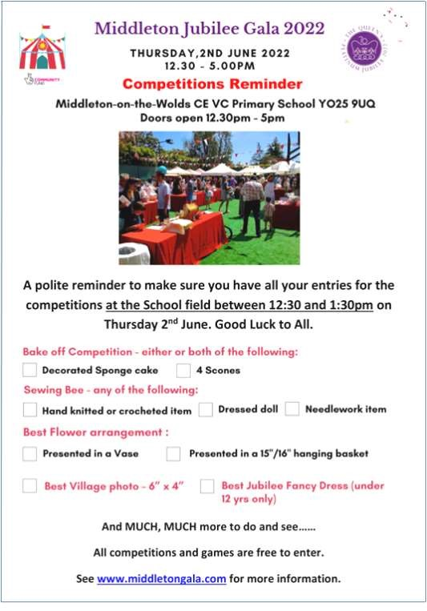

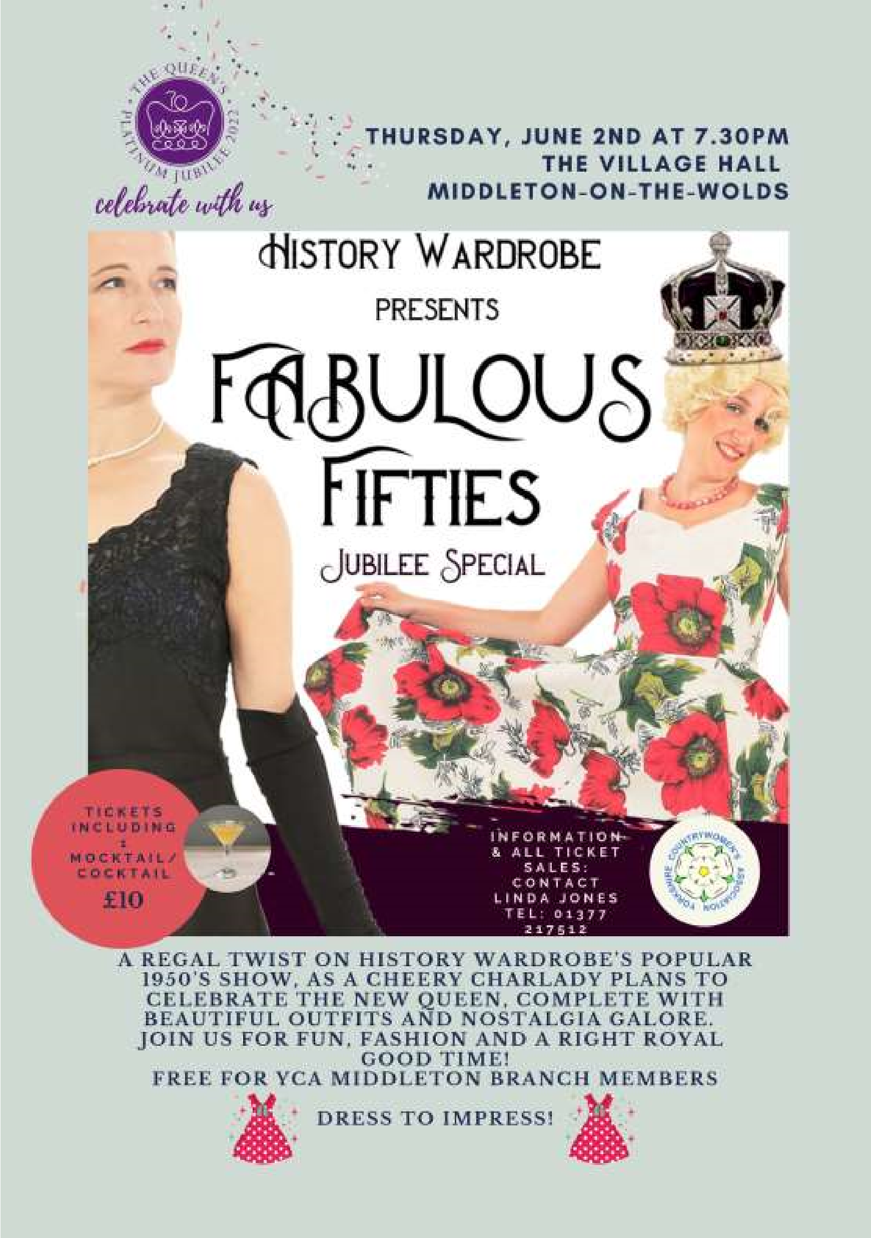

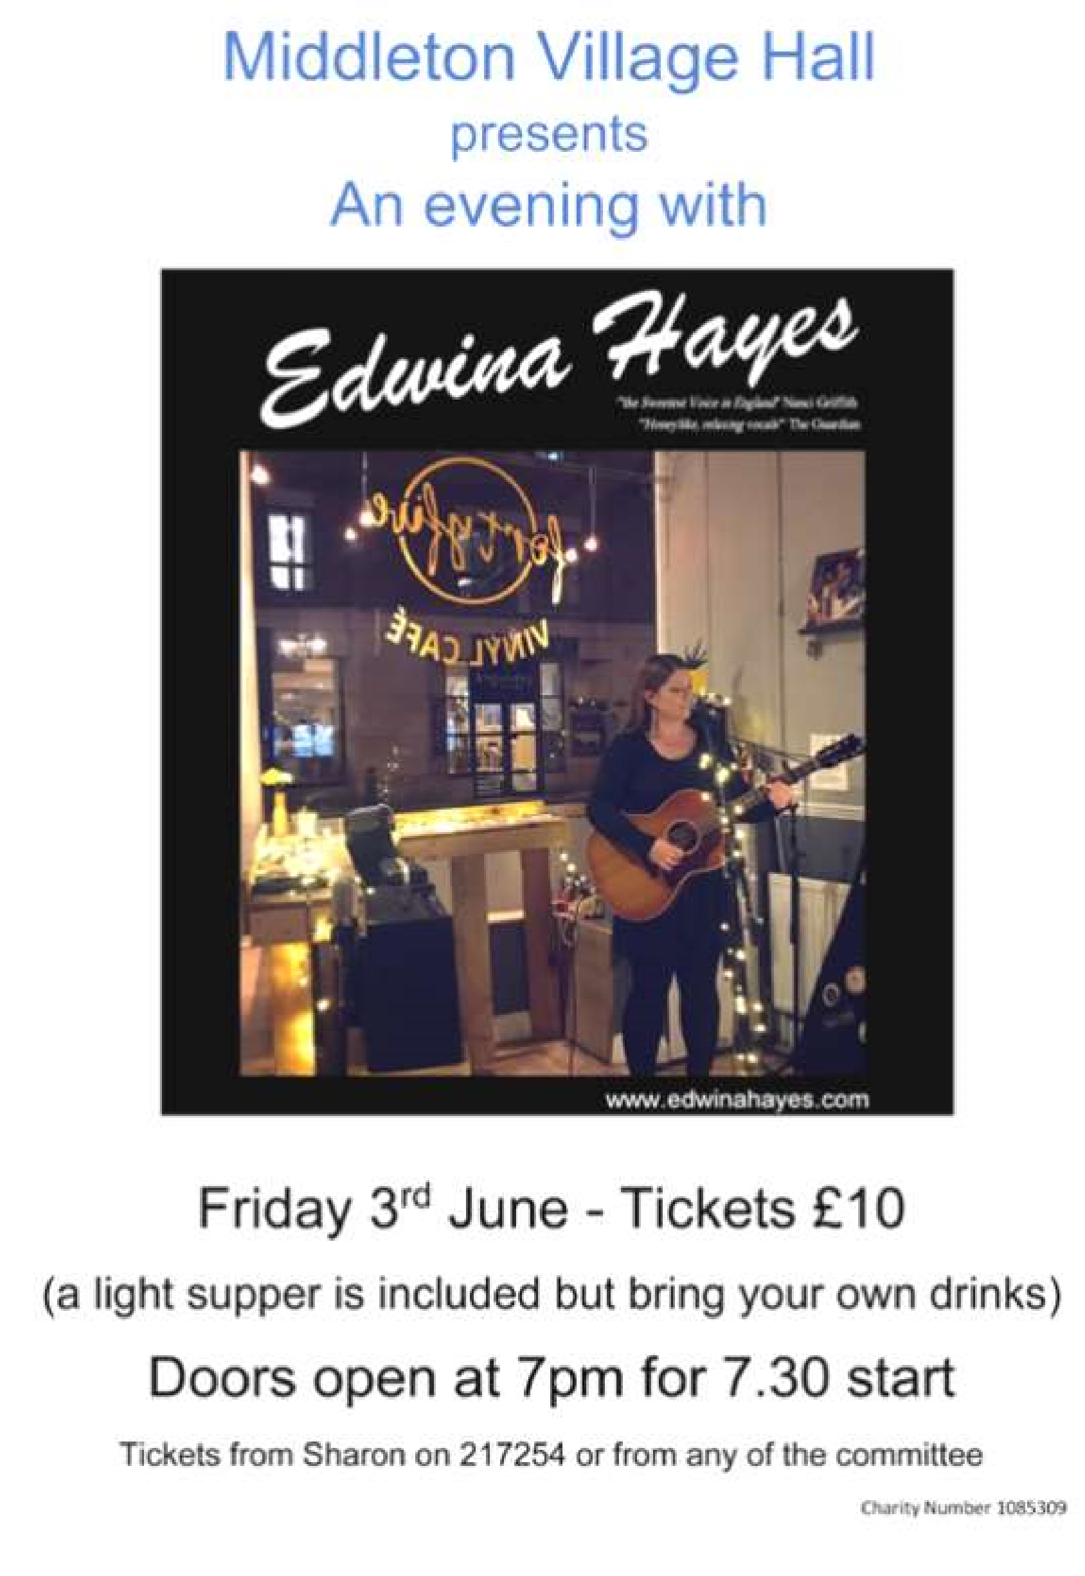

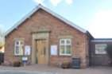
Village hall
We have managed not to increase the price of hiring the hall for 6 years but, with the increased energy and maintenance costs there will be a small increase of
50p per hour from 1st June. The charges will now be:
£8.50 per hour, £30 per 4 hours, £54 per 8 hours
I am sure you will agree that it is still very good value especially with the improved facilities.
If you would like to hire the hall for a family party or group function please contact Lyn on lyndennis456@gmail.com or 219500.
Our thanks go to Denise Wales for all her help on the committee over the last few years. She was instrumental in sourcing the grants that have enabled us to renovate the hall and in organising the Easter Fair (amongst other things). Unfortunately she is having to leave the committee - she will be sorely missed.
We are now down to only 4 working members on the committee. If you would like to come along to one of our meetings, which are now held on the first Wednesday afternoon in each month at 2.30pm, you would be made most welcome and we would be able to give you an idea of what would be involved.
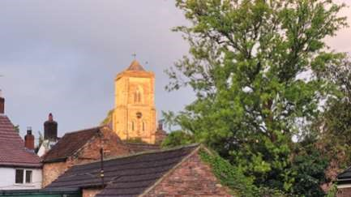
The picture was taken from the Village Hall during Line Dancing one Wednesday evening in May as the sun was going down.
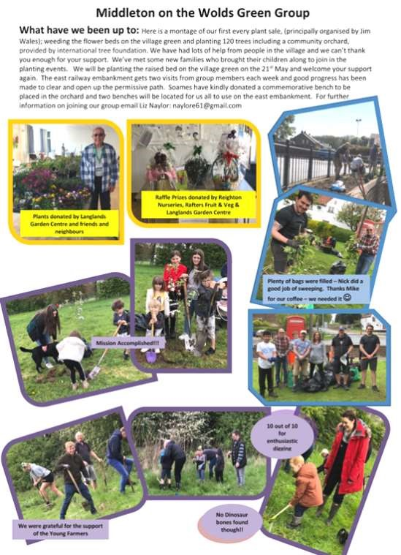

Middleton on the wolds ce ve school
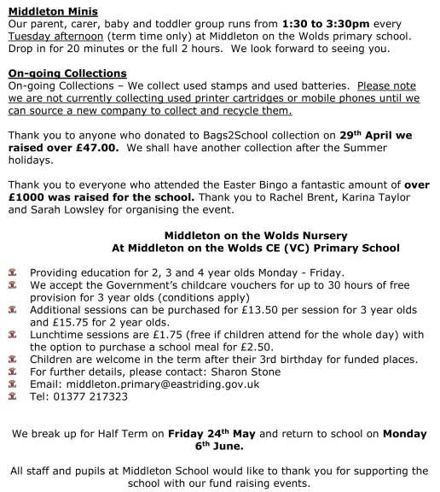
Executive Headteacher: Mrs E Harros

Station Road, Middleton on the Wolds, Driffield YO25 9UQ

E
-
mail:middleton.primary@eastriding.gov.uk Tel: 01377 217323

parish council news

Chairman’s Annual Report
It has been a year of interesting and varied challenges, from dealings with the County Council and the proposed housing development to issues with the Rec Club and the uproar over the Embankment, which we have dealt with with varying degrees of success.
We have had very positive collaboration with Highways which has led to much of the outstanding work being done. It’s a start but we are still waiting for some of the bigger jobs, especially resurfacing Front Street, to be done. On the other hand, our dealings with Planning have been less successful, especially concerning Beacon Park and ‘Gate gate’. Now, you might say that we should have been more on the ball regarding planning permission and potential change of use, but we followed all the available information regarding the gate, and who would have thought that changing a field of grass into a grassy field would constitute a change of use? As to the beacon, I would have expected a more sympathetic application of planning rules.
Regarding the embankment we should have communicated more fully and certainly been less confrontational. However, by standing our ground we were able to establish the parameters of what work could be done and how. We now have the Green Spaces group, which is very active and effective and, in all fairness, could be used as a model of how such a body should be set up and operate so much good has come of the situation.
We have also been at loggerheads with the Rec Club, firstly over the new play equipment and, more recently, over the question of funding. Again, we may have gone in a little hard on both of these issues, but we have been able to put forward our position and have since managed to rebuild bridges between the PC and Rec Club. I don’t mind the slanging matches as long as we can keep talking!
How have we dealt with the issue of the proposed housing development? We have consulted with residents, and we have challenged the assumptions made in the proposal without directly coming out against it. And that is important because not everyone is against the development, and we must represent the whole village. We will continue to press the county council and the developer to ensure that any development will be sympathetic to the conditions existing in the village.
As last year, most of the above issues boil down to less than effective communication between us, individually and as a group, and our stakeholders. I think we are getting better, but we are not there yet.
From an internal point of view, we have lost two councillors and have not yet been able to get replacements. The only qualification for being a parish councillor is, basically, living or working in the parish That’s it. So, please, think about joining us.
And finally, I want to thank our ward councillors, especially Kevin Beamont and Pauline Greenwood, for their active support throughout the year.
Mike Kelly
Chair of the Parish Council

BEACON INSTALLED FOR JUBILEE CELEBRATIONS
In May the Parish Council installed a beacon in the Beacon Field ready for the Jubilee celebrations. Commissioned by the council it was constructed locally and installed with help and support from Ben, a local farmer and East Riding Council. It will eventually carry a village shield which will be chosen from designs submitted by villagers in a competition and will be a shining landmark for all to see both from within the field and from the road. Next months’ Messenger will contain a report of its inaugural lighting for the Queens Jubilee celebration.
Nick Jones

The Parish Council plans to light a Beacon for The Queen’s Platinum Jubilee on the evening of Thursday, June 2, 2022, at 9.45PM.
The Beacon is one of thousands being lit in the UK and the Commonwealth, and forms part of the official programme announced by Buckingham Palace for the Jubilee Weekend.
The Beacon will be lit at Beacon Park, and it will be one of over 2,022 lit by charities, communities and faith groups all over the UK.
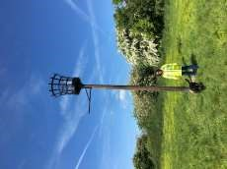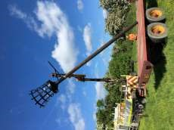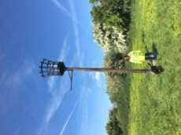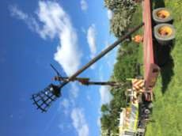
Mike

Middleton book group
Flappy Entertains by Santa Montefiore. Flappy Scott Booth is the queen bee of Barley Compton. Her exacting standards instil fear into the hearts of her 'subordinates'! This is until she comes under the spell of the dashing Charles when standards decidedly slip! A happy, undemanding book which most enjoyed.
The Inheritance by Jenny Éclair. A family saga revolving around Kittiwake, a mansion on the Cornish coast. Peggy, an American heiress restores the house but following the drowning of her eldest son can no longer bear to live there so moves to London. The story follows the history of the house and family culminating in the 50th birthday party of the heir, Lance which ends in tragedy. The book was generally enjoyed by the group.
Pam read some of Henry Brewis, entertaining, farming inspired poems which everyone enjoyed
Lindsay
My first choice for May, An Act of Love by Carol Drinkwater tells the story of Sara and her parents who are forced by the Nazis to flee Poland. As with most of her books, Carol relies on knowledge of her local habitat of Southern France where she has an olive farm. This book is mainly set in a village in the French Alps where the family are welcomed and looked after by the small community until the Nazis once again threaten their lives. Everyone had read Carol’s book and enjoyed it on the whole. It provoked a fair amount of discussion.
I thought it was about time we read a Lynda la Plante book so decided on Judas Horse which is the second in the Detective Jack Warr series. Jack is seconded to The Cotswolds to use his skills to solve a series of violent burglaries in affluent houses and enlists the help of a woman who is involved with the gang. This was only read by 4 of us and the general opinion is that she has written better books.
Lyn
Meetings are on the second Tuesday in the month. To find out more about the Book Group please contact Lyn on 219500 or lyndennis456@gmail.com

The next books for discussion are:
When Hitler Stole Pink Rabbit by Judith Kerr
Morality for Beautiful Girls by Alexander McCall Smith
Feeling patriotic? Why not try your hand at this crowdpleaser
Union Jack Cake by Nadia Sawalha
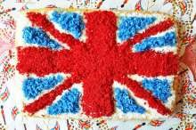
INGREDIENTS
225G BUTTER
225G CASTER SUGAR
4 EGGS
225G SELF-RAISING FLOUR 1 TSP VANILLA EXTRACT
-------------------------
LEMON CURD
500G DESICCATED COCONUT
RED & BLUE FOOD COLOURING

Heat the oven to 180C/gas mark 4. Butter and line a rectangular 20x30cm tin. Put the butter and sugar into a bowl and whisk until light and fluffy.
Gradually add the eggs, whisking the entire time, and fold in the flour and vanilla extract. Pour into the prepared tin and bake for 40 minutes until light golden-brown.
Allow to cool on a wire rack, then spread lightly with lemon curd and cover the entire cake in white coconut.
Separate the rest of the coconut into two bowls. Put two thirds of it in one and the remaining third in the other. In the bowl with two thirds, put five to six drops of red food colouring and mix well, adding more colouring if necessary.
Put the same amount of blue food colouring into the other bowl and mix thoroughly. Then sprinkle the coloured coconut onto the cake in a Union Jack shape. Place in the centre of the table and show off your hard work.

Recipe courtesy of The Eden Project Big Jubilee Lunch www.edenprojectcommunities.com
CELEBRATE

1.

The opening of parliament

2.

Lady in waiting

3.

Changing of the guard

4.

For Queen & country

5.

George Cross

6.

Sandringham

7.

Long to reign over us

8.

New Year
’
s Honours

9.

Royal Highness

10.

Christmas Broadcast

1

Lilibet,

2

England

3

Derby

4

Dubonnet

5

Barbie ( in her likeness)

6

Five (Elizabeth Woodville, wife of Edward IV, 1465. ,

Elizabeth of York, wife of Henry VII and mother of Henry VIII,
1487

Elizabeth I of England and Ireland, 1559,

Elizabeth Bowes
-
Lyon, wife of George VI,1937

Elizabeth II,1953.)

7

Palaceof Holyroodhouse, a former royal residence of Queen Mary.

8

Helen Mirren

9

Twelve

10

Winston Churchhill

11

Bonus Question

Estimated £72.5 Billion

QUIZ ANSWERS

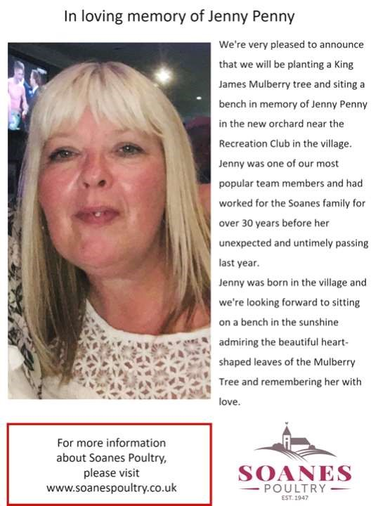
Advertising Feature
Advertisements
Advertisement

Advertising Feature

Regular group activities
Weekly Groups
Monday Pilates | 5.00-6.00pm Village Hall
Tuesday Tai Chi | 2.30-4.00pm Village Hall
Wednesday Line Dancing | 7.30-9.00pm Village Hall
Thursday Middleton Movers  June | 2.00-3.30pm Village Hall
6 Parish Council | 7.00pm Reading Rooms
8 Village Hall Committee | 2.00pm Village Hall
14 Book Group | 10.30am Greenfield Road

LOCAL CONTACTS Bell Ringing Chris Atkin |  | 217285
Book Group/Middleton Movers | Lyn Dennis | 219500
Bowls Club | Rob Bradley | 217435
Country Women’s Association | Christine Johnson | 217374
First Responders | Chris Brent | 219469
Line Dancing | Pat Pottage | 217516
Methodist Chapel | Jane Gray | 07870 562455
Middleton Messenger | Mike Kelly | 07713 620912
 | Lyn Dennis | 219500
 | Tina Walker | 217242
Middleton Green Group | Liz Naylor | 219072
Middleton Womblers | Andrew Naylor | 219072
Parish Clerk | Sandra Morrison | 01262 470496
Pilates | Ian Stephenson | 07973 755717
Reading Rooms | Kath Bentley | 217456
Recreation Club | Dave Newlove | 07901 833784
St Andrew’s Church | Rev Jane Anderson | 219471
St Andrew’s Church Wardens | Chris Brent | 07766 162743
 | Lesley Kelly | O7907 451046
Table Tennis | Louise Newlove | 217801
Village Hall | Lyn Dennis | 219500
Village History Geoff Wisher |  | 217517
email: middletonflyer@yahoo.com page 28

